First Baptist Preschool
2709 Monument Avenue
Richmond, VA 23220
(804) 358-5458, ext. 155

Information & Fact Sheet 2019-2020
Preschool Administrator: Alex Hamp (hamp@fbcrichmond.org)

PHILOSOPHY: We believe young children need a learning environment which will nurture each child as a unique and valuable child of a caring God. Our curriculum encourages the total development of each child - SPIRITUALLY, SOCIALLY, EMOTIONALLY, INTELLECTUALLY, and PHYSICALLY. We encourage a strong feeling of self-confidence and respect for others. We provide first-hand opportunities for each child to grow by OBSERVING, INQUIRING, EXPLORING, CREATING, ASKING, SEEKING, and FINDING.

It is our desire to provide a caring Christian atmosphere which will nourish personal and spiritual growth.
Our professional staff of teachers provides a warm, loving environment for your child. Each class has a teacher and an assistant teacher.

The following classes are offered: Class size (up to)

Babies Class 2 days: Tuesday & Thursday mornings or 8 (8months by Sept 9, 2019) 3 days: Monday, Wednesday, & Friday mornings or
&Toddler Class 5 days: Monday-Friday mornings
(1 by May 31, 2019)

2’s Class 2 days: Monday & Wednesday mornings or 13
(must be 2 by 3 days: Monday, Wednesday, & Friday mornings or
September 30, 2019) 5 days: Monday-Friday mornings

3’s Class: 3 days: Monday, Wednesday, & Friday mornings or 15
(must be 3 by 4 days: Monday - Thursday morning or
September 30, 2019) 5 days: Monday - Friday mornings

Pre-K: Monday - Friday mornings (9:00 a.m.-1:00 p.m.) 15
(must be 4 by
September 30, 2019)

*Our class age requirements correspond with Virginia State Law of children needing to be age 5 by September 30th to begin Kindergarten

HOURS: All Preschool classes meet from 9:00 a.m. to noon except for the Pre-K classes which meet from 9:00 a.m. to 1:00 p.m.(the Prek children eat lunch at school). Early morning drop-off (beginning at 8 a.m.) and a Lunch Bunch Program are also available.

RELATIONSHIP TO FIRST BAPTIST CHURCH:
Our preschool is viewed as a ministry of First Baptist Church. The church provides our space and utilities, and appoints a Preschool Board which meets regularly to review budget, tuition, and needs or concerns expressed by the administrator.

AFTER FIRST BAPTIST: Our "graduates" attend a variety of public schools and private schools.

REGISTRATION PROCEDURES FOR THE 2019-2020 SCHOOL YEAR
1. Registration is a written process and the responsibility of individual parents/guardians.

2. The registration fee of $50.00 (non-refundable) must accompany each application. The $50.00 fee will be applied to your tuition.

3. Applications may be turned in anytime. Applications from currently enrolled students, their siblings, and First Baptist Church members will be processed first beginning Wednesday, January 16, 2019.

4. All other applications will be processed beginning Monday, January 21, 2019.

- As space is limited, all parents/guardians (both returning and new families) are encouraged to return their child’s application and registration fee as soon as possible.

- Applications for children with special needs will be reviewed on an individual basis.

- First Baptist Preschool does not discriminate on the basis of race, color, gender, national, or ethnic origin.

- Acceptance letters and contracts will be mailed by February 15, 2019. Returned contracts and a $150 deposit will be due on March 29, 2019.

FEES FOR THE 2019-2020 SCHOOL YEAR
Registration Fee: $50.00 (non-refundable) fee must accompany your application. This $50.00 fee will be applied to your tuition. We offer a 5% discount for church members. There is a $100 sibling discount for the 2nd (and subsequent) child(ren) who are enrolled AT THE SAME TIME. A limited number of need-based scholarships are available. Application forms are available online or by request, and should be submitted along with the child’s registration form.

Tuition: 2 mornings: $2200
3 mornings: $2800
4 mornings: $3400
5 mornings: $3800
Pre-K (9 a.m.-1 p.m.): $4650

Tuition may be paid over a 9 month period from September through May. Tuition can also be paid in 4 installments, or in full.

It is understood that a child admitted to the First Baptist Preschool is to be enrolled for the entire school year. If it becomes necessary to withdraw the child from school, the parents are responsible for the full yearly tuition unless the child's space can be filled.

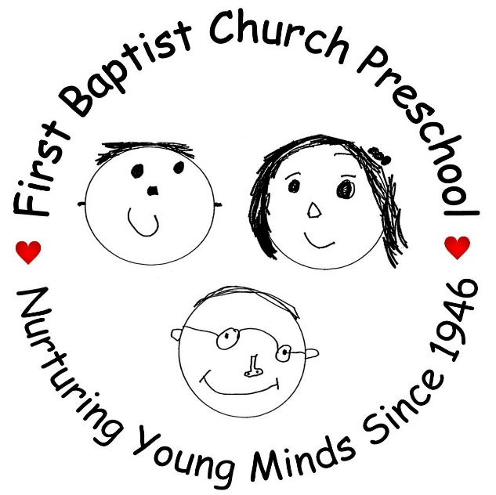
FIRST DAY OF SCHOOL: September 9, 2019
Visit our website at: http://www.firstbaptistpreschoolrva.com
Like us on Facebook: First Baptist Preschool
Follow us on Instagram @firstbaptistpreschoolrva

