FIRST BAPTIST PRESCHOOL
Richmond, Virginia
PARENT HANDBOOK
2021 ~ 2022 School Year
First Baptist Church Preschool
Nurturing Young Minds Since 1946
♥
♥
♥
First Baptist Church Preschool
Nurturing Young Minds Since 1946
♥
♥
First Baptist Church Preschool
Nurturing Young Minds Since 1946
♥
♥
First Baptist Church Preschool
Nurturing Young Minds Since 1946
♥
♥
First Baptist Church Preschool
Nurturing Young Minds Since 1946
♥
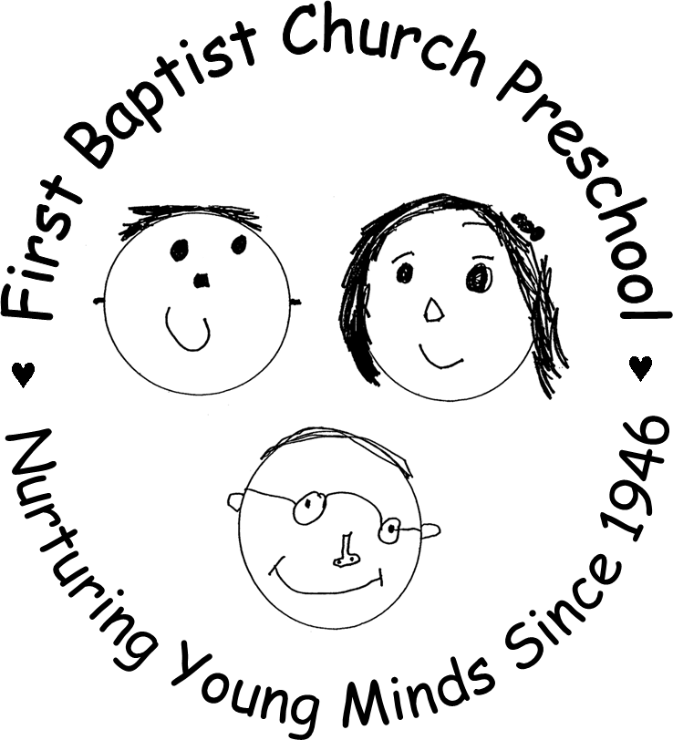
First Baptist Church Preschool
Nurturing Young Minds Since 1946
♥
♥

Preschool Office 804-358-5458, ext. 155
Alex Hamp, Director hamp@fbcrichmond.org
First Baptist Church 804-355-8637

TABLE OF CONTENTS

Letter from Alex Hamp, Preschool Administrator 2

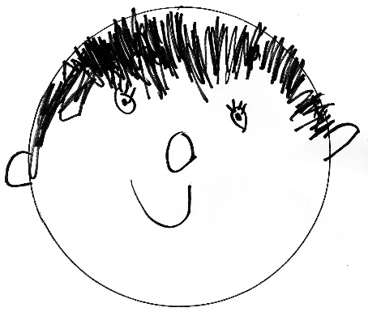
Statement of Philosophy 3-4

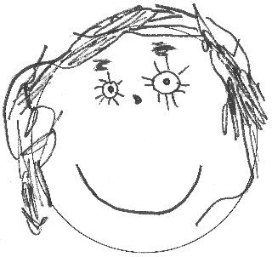
School Policies
Arrival 5
Attendance 5
Birthdays 5
Biting ……………………………………………………………………………………… 5
Center Approach 5
Church Support 6
Class Visits 6
Conferences 6
Diapers/School Bags 6
Discipline 6
Dismissal …………………………………………………………………………………..7
Dress 7
Early Morning Drop-Off 7
Enrichment 7
Enrollment Termination 7
Extended Day/Lunch Bunch 7-8
Fees 8
First STEP Class 9
Field Trips 9
Health/Sick Policy 9-10
Insurance 11
Ladder of Communication 11
Late Pick-Up Fees 11
Parents as Partners…………………………………………………………………… 11
Parent Teacher Organization (PTO) 11
Placement in Class 12
Safety 12
Scholarships and Fund Raisers 13
School Closings 13
Snacks 13
Toilet Training 13
School Year Calendar 14

First Baptist Preschool
2709 Monument Avenue
Richmond, Virginia 23220
hamp@fbcrichmond.org
358-5458, ext. 155

Alex Hamp
Administrator

Dear Parents/Guardians,

Welcome to the First Baptist Preschool program! We are busy planning many exciting learning opportunities for your child, while working to provide a safe environment. Our school year officially begins on Monday, September 13th.

We invite you and your child to our Class Visits on September 9th and 10th. Your child’s teacher will contact you with a time for your visit by mid August. These visits are generally 20 minutes long.

Please read this handbook to become familiar with our school’s policies and procedures and ask any questions you may have. As things continue to change, and new information is shared with us from the CDC and Virginia Health Department, there may be updates/changes to our policies.These will be communicated via email closer to the beginning of school.

After reading the information in the handbook, please click on the link in the welcome email to sign the letter that highlights our closing polices and confirm that you have read the information in this handbook. (This is a state regulation.)

Sincerely,

Alex Hamp

STATEMENT OF PHILOSOPHY

WE BELIEVE children need a learning environment which will:

♥ nurture each preschooler as a unique and valuable child of a caring God

♥ encourage the total development of each child (physically, socially, spiritually, emotionally, and intellectually)

♥ encourage a strong feeling of self-confidence and respect for others

♥ provide first-hand opportunities for the child to grow

♥ by observing

♥ by inquiring

♥ by exploring

♥ by creating

♥ by asking

♥ by seeking

♥ and by finding
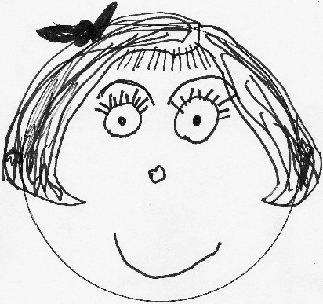
.

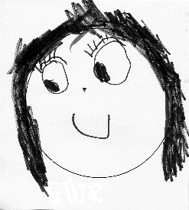

STATEMENT OF INTENT
First Baptist Preschool is a religiously exempt preschool located at 2709 Monument Avenue Richmond, Virginia, in the First Baptist Church building. Our school can serve up to 160 students ranging in age from eight months (by the first day of our school year) through six years, ten months. Our school utilizes fifteen classrooms in the approximately 250,000 square foot church building. In addition, we use a full size gym and two playgrounds that are on the property. A daily snack or lunch is brought from home. Our preschool students and visitors are covered by the Church’s public liability insurance policy.

All of our teachers are certified annually to be in good health and free from any disability which would prevent them from caring for children. All of our classes have two teachers, a lead teacher and an assistant. Our lead teachers hold a college degree, or have experience that is comparable. Both teachers and assistant teachers are certified in CPR and First Aid training. They are also required to have a minimum of ten hours of staff training annually.

Because we encourage the total development of each child (spiritual, social, emotional, physical and intellectual), a variety of purposeful activities are planned each day to support the concepts that are being introduced and meet individual needs. During the free choice of activities, teachers and assistant teachers will offer guidance, motivation, and encouragement to children on a one-on-one basis or in small groups. In this manner, we feel we can build upon the concepts already formed and introduce new ones at appropriate times for each child.

Included in the schedule are times for social interaction, which will encourage your child to expand his/her vocabulary and learn to express his/her thoughts and feelings to others.

A chapel time for three, four, and five year olds will include a Bible story, music, and prayer. Music class for three, four, and five year olds occurs once a week.

Using our two playgrounds and full size gym, a balance of large and small motor activities is provided to enhance important physical growth.

It is our desire to provide a warm and caring atmosphere which will nourish personal and spiritual growth. Through association with dedicated teachers, and with age appropriate activities, each child will be encouraged to grow in love and appreciation of a caring God. Mission projects will be offered throughout the school year beginning in September. We hope you will help us teach your child to care for others and to love your neighbor by participating in our mission projects.

First Baptist Preschool does not discriminate on the basis of race, color, gender, or national or ethnic origin.

ARRIVAL
For this 2021-22 school year, parents will drop their child off at an assigned door on the portico or at the Monument Avenue Playground side. By virtue of bringing your child to school each morning you are attesting that the child is in good health, free of any illness like symptoms. A staff member will ensure that your child gets to his/her classroom. To allow the teachers time in the mornings for ample set up and planning, we ask that you arrive promptlybetween 8:55-9:10. For anyone who arrives after 9:15, please come to the the receptionist desk on Mulberry so the director (Alex Hamp) or child’s teacher can come greet you and your child and bring he/she to his/her classroom.

CRITICAL SAFETY INFORMATION:
- Please hold children’s hands when walking through the parking lot.
- Please do not allow your child to come into the building alone, to go upstairs or go on the elevator alone (for our oldest students).
- Please make sure that your child is WITHIN REACH AND SIGHT AT ALL TIMES when you are on the portico, the sidewalks, or in the parking lot.
- Our parking lot is a cell phone free zone.
- If walking your dog to school, please do not bring dogs onto the portico.

ATTENDANCE
Please email or text your child’s teacher AND email Alex Hamp at hamp@fbcrichmond.org by 9:30 a.m., when your child is sick or will not be attending school for any other reason.

BIRTHDAYS
For children who will turn 3 and older, please come and share your child's birthday with us at school! Your child will make a gingerbread cake here at school or a treat may be brought. Your child’s teacher will let you know her preference. Please also plan to read one of your child’s favorite books to the class. In addition, some parents like to donate the book to the preschool in honor of their child.

BITING
Biting can be a normal stage of development for young children who are teething or still developing language and communication skills. However, the preschool takes biting seriously. Our teachers supervise activities to limit biting but there are times when a teacher cannot be within immediate reach to stop a bite. When a bite does occur, the biting child is removed from the situation and spoken to on a level he/she can understand. The bitten child is consoled, the area is washed, and ice is applied. If skin is broken, the parent will be contacted. For each known bite, an incident report form is completed and a copy is given to the parents of all children involoved. If a child bites more than once in a day, a parent may be called to come pick up the child from school.

CENTER APPROACH
Each classroom is set up daily with varying learning centers for purposeful play - art, blocks, books, home living/dramatic play, music, nature/science, manipulatives, and sensory table. Children are provided free choice in moving from one area to another with teachers and assistant teachers offering guidance one-on-one or in small groups.

CHURCH SUPPORT
First Baptist Preschool is 75 years old! We are proud of our role in providing the best quality preschool experience for children in the Richmond area. First Baptist Preschool is viewed as a community ministry made available through this facility. First Baptist Church provides our space. The Church appoints an advisory board which meets to review budget, tuition, and needs or concerns expressed by the administrator.

CLASS VISITS
Students and Parents are invited to come visit their classroom on September 9th and 10th at a set time. This gives you and your child the opportunity to explore the classroom with another student and a chance to meet the teacher for 20 minutes. Your teacher will be in contact by August 20th with a time for you to visit.

CONFERENCES
Parent/Teacher Conferences are scheduled on Friday, December 3, 2021 from 8:30-12:30pm. There is no school that day. Childcare is available for your enrolled child during your conference time, if needed. If you have concerns at any other time, please reach out to your child’s teacher, or Alex by email or by voice mail at 358-5458, extension 155, with your questions or concerns. We will also offer conferences in May for Prek, or for any parent who requests it.

DIAPER/SCHOOL BAGS
A well-stocked diaper bag/school bag includes 3 diapers, wipes, and a complete set of clothes (even socks!). Wet pants are not the only accidents at school. Spilled water or paint often necessitates changing a child's clothing. Please label the diaper bag/school bag and clothing. A labeled snack (lunch for PreK) and cup for water should also be sent in the bag.

DISCIPLINE
The following methods are used by our faculty to encourage cooperative behavior:
1. Giving positively worded directions: You may sit on the floor or on a chair. Walk inside. Run outside or in the gym. Remember to use your words.
2. Redirection: Substitute a positive activity for a negative activity. (You may throw a beanbag - we use blocks for building.)
- Distraction: Change the focus of the activity.
4. Positive reinforcement: “Try to catch a child being good” affirming a child’s appropriate behavior.
5. Active Listening: Helping the child determine why there is a problem and helping the child acknowledge his/her feelings and/or reaction.
6. Separation from the group: When all of the above fails, only then is a child briefly (less than 5 minutes) separated from his/her classmates. The child will always be within sight of the teachers.
7. Better Choice: We use the phrase “making a better choice” instead of time-out.

PHYSICAL PUNISHMENT AND SHAMING METHODS ARE NEVER USED.

DISMISSAL
To mitigate traffic in the school building, dismissals will be handled similar to arrival time, except our Two’s Classes who will be picked up from their classroom

DRESS
Since children learn by engaging in "hands on" experience, we will be participating in fun activities such as painting, play dough, gluing, etc. Please send your child to school dressed comfortably, in play clothes which will wash easily. For your child’s safety, please have him/her wear tennis shoes. Sandals, clogs, boots, cleats, and crocs are not safe for children at school. Please be sure to label all coats or any removable clothing.

EARLY MORNING DROP-OFF
This option is available in an attachment that is in our Welcome Email. Forms to register your child are due back by August 1st. This option will be available beginning Tuesday, September 14th. Only enrolled children may come anytime between 8:00-8:50 a.m. to the Church Gym. Payment for Early Morning can be paid in your monthly tuition, or in the four installment plan.

ENRICHMENT
In addition to the regular classroom schedules, all children in the 3 & 4’s and Pre-K/JK classes attend the following: Music, Library, & Chapel. If State guidelines allow, we will offer other classes after school, such as Soccer Shots and Wee Little Arts. These classes are only offered for the children in our 3’s and Up classes, even if your child turns 3 during the school year.

ENROLLMENT TERMINATION POLICIES
It is understood that a child admitted to First Baptist Church Preschool is to be enrolled for the entire school year (September - May). If it becomes necessary to withdraw the child from school, the parents must give a 4 week notice to the administrator. This notice must be in writing. The parents are responsible for the full yearly tuition unless the child's space can be filled. Exceptions to this may be considered due to extenuating circumstances, such as a family move outside the greater Richmond area or due to the recommendation of a physician licensed to practice in Virginia.

First Baptist Preschool reserves the right to terminate the school contract and require the withdrawal of any child enrolled in the program if the school, in its sole discretion, considers such withdrawal to be in the best interests of the school. If the withdrawal is required by First Baptist Preschool, the affected family shall receive a pro rata refund of any tuition payments previously made, depending upon the date of the withdrawal.

EXTENDED DAY PROGRAM (LUNCH BUNCH)
Lunch Bunch will begin on the first day of school, September 14th. Similar to Early Morning, all requests for Lunch Bunch/Extended Day are found in attachment in email and due back by August 1st. The purpose of this program is to provide both additional center time and gross motor skill development for your child. The cost for this program is as follows:

Lunch Bunch:  Monday through Friday 12-1PM | Lunch Bunch Cost
Over 2 | $325 per day for year
Under 2 | $400 per day for year

Extended Day:  Monday through Thursday 1-3PM | Extended Day Cost
Must be in Threes and older classes | $625 per day for year

Children must be enrolled for the entire school year. Payment may be made in your monthly tuition or in the four installment plan. “Drop Ins” may be offered if there is space. The cost is $12 per hour. Please email Alex for availability if a drop in is needed.

LUNCH BUNCH/EXTENDED DAY PROCEDURES
- Your child will need to bring a packed lunch and water cup. PLEASE REMEMBER WE ARE A PEANUT FREE SCHOOL, AS YOU MAKE YOUR CHILD’S LUNCH. No juice boxes or gogurts, as they prove to be quite messy! Please send in a spoon if your child’s lunch requires one. Please label all non-disposable containers.
- Your child will have the opportunity to play in the centers and with manipulatives and games set on the table after the lunch hour. For extended day, an open ended art table will be offered. We will also go outside or the gym for gross motor development. Children will eat a snack brought from home at 2:30.
- Please be prompt in picking your child up on the hour. LATE PICK-UPS WILL BE ASSESSED A LATE FEE OF $5 FOR EVERY 10 MINUTES AFTER THE HOUR. IF YOUR CHILD IS NOT PICKED UP BY 3:10, HE/SHE WILL BE TAKEN TO ALEX’S OFFICE. TEACHERS ARE NOT EXPECTED TO STAY PAST 3:10.
- Unfortunately due to the popularity of Extended Day, we will not be able to change days if your child is absent on his/her extended day.

FEES: 9am-12pm (1pm for PreK)TUITION
The tuition chart below is for morning classes only! Registration fees and deposits are credited towards your total tuition.Tuition can be paid through our online portal: https://fbcrichmond.myshelby.org/Financials/portal. A User ID and Password will be issued to each family to log in. When paying online we ask that you pay using an electronic check (ACH). If not possible by ACH, VISA & Mastercard will be the accepted credit cards this year.

Date due | 2 day class | 3 day class | 4 day class | 5 day class | Pre-K/JK
 | $2300 | $3000 | $3600 | $4000 | $4900
Reg + $150 deposit already paid with contract | $200 | $200 | $200 | $200 | $200
08-15-21 | $525.00 | $700.00 | $850.00 | $900.00 | $1175.00
10-15-21 | $525.00 | $700.00 | $850.00 | $900.00 | $1175.00
01-15-22 | $525.00 | $700.00 | $850.00 | $900.00 | $1175.00
03-15-22 | $525.00 | $700.00 | $850.00 | $900.00 | $1175.00
Monthly:Sep-May | $233.00 | $311.00 | $373.00 | $422.00 | $522.00

When you log into our portal, you will find an invoice with your amount due. If you click on the small magnifying glass on the invoice, you will find a description as to each charge. ALL MONTHLY TUITION IS DUE ON THE 15TH OF EACH MONTH. Quarterly tuition is due on the dates in the chart above. There is a 10 day grace period to pay your tuition. After the 10th day, a 5% late fee will be added to any late invoices. Unfortunately, the system does not have the ability to set up reoccurring payments. The Director sends out numerous reminders when tuition is due.

*First invoices for the 2021-22 School Year will not be posted until August 10th. If you find any mistakes on your invoice, please contact Alex before making a payment.

Church members receive a 5% discount on tuition. There is a $100 sibling discount for the 2nd (and subsequent) child/ren IN THE SAME FAMILY who are enrolled AT THE SAME TIME.

FIRST STEP CLASS
We are excited to partner with the ASK Childhood Cancer Foundation to provide preschool for children or siblings who are affected by cancer or other childhood diseases. We are one of two preschools in the country who have this special partnership! The First STEP (Socialization Through Enriched Play) class meets on Tuesdays and Thursdays.

FIELD TRIPS:
Because we feel it is important for children to have first-hand experiences in the world around them, our Pre-K children will be taking several field trips during the year. Parents will be needed to drive for our field trips. We are able to carpool, but any parent driving another student will need to provide a copy of their driver’s license and insurance card to Alex before the trip. This is a State regulation. Due to insurance regulations, siblings of our students may not accompany parent helpers on field trips.

HEALTH
The Commonwealth of Virginia School Entrance Health Form, a record of a completed physical examination and up-to-date immunizations, IS REQUIRED BY AUGUST 20, 2021 FOR ALL NEW STUDENTS AND ANY CHILD WHO ATTENEDED OUR PROGRAM LAST YEAR UNDER THE AGE OF TWO. For ALL returning students, an updated immunization record is needed. Up-to-date immunization information will also be required in February 2022 for children under the age of two years.

Please make us aware of any atypical health information, including, but not limited to, allergies, anaphylaxic medications, tendency to seizures or chronic illness.

As a religiously exempt preschool, we require that our students be current in all immunizations as set by the Centers for Disease Control for the safety and health of all children at First Baptist Preschool. Decisions on exceptions will be made on an individual basis, considering the recommendation of the relevant pediatrician.

Prescription medication, with the exception of anaphylaxic medications and inhalers, is generally not administered by our faculty. Parents and a health care provider are required to complete a form authorizing the administration of any of these medications. This form is available from Alex Hamp.

Skin products, such as sun screen and insect repellant, will not be administered by our preschool. Parents should be mindful that children will be outside at least 30 minutes per day and should apply these products as needed before the child arrives at preschool. Exception:
Diaper ointment or cream will be applied as needed, but only when provided by the parent. Please send ointment, marked with your child’s name, to be kept in your child’s classroom.

GENERAL SICK POLICY
For the safety of all, we do a quick visual daily health check at arrival. We ask for the protection of your child and others, and to help prevent the spread of illness, that a parent keeps a child at home when he/she has any of the following symptoms:

- A temperature of 100 degrees or more (without fever-lowering medication)
- A heavy nasal discharge
- Cough that interrupts child’s play
- Vomiting or diarrhea within the past 24 hours
- Any communicable illness or disease
- Head lice/nits

Please note that there are other symptoms of illness that may keep your child out of school, which are not listed above. Your child may also need to stay home in the two following situations:
- When he/she is fussy, cranky and generally not him/herself, it is often the first sign of ensuing illness.
- When you have one sick child at home, it is frequently wise to keep siblings home also, as they have already been exposed to the illness in question and are likely to transmit it to their classmates as well.

Please be vigilant as to unusual symptoms or behaviors in your child which might indicate illness. The preschool will also be observant and if your child becomes ill at school, you will be notified to come for him/her immediately. ANY CHILD SENT HOME DUE TO ILLNESS WITH A FEVER WILL NOT BE READMITTED BACK TO SCHOOL WITHOUT A DOCTOR’S NOTE STATING THAT THE CHILD IS READY TO RETURN TO SCHOOL.
PLEASE NOTE: YOUR CHILD MUST BE SYMPTOM FREE, WITHOUT MEDICATION, FOR AT LEAST 24 HOURS BEFORE RETURNING TO SCHOOL.

Please notify the school immediately if your child contracts a communicable illness or disease.
COVID RELATED SICK POLICY
If your child exhibits any of these following symptoms, it may be COVID 19 related:
• Fever of 100 degrees Fahrenheit or higher
  - • Dry cough
  - • Shortness of breath
  - • Chills
  - • Loss of taste or smell
  - • Sore throat
  - • Muscle aches
  - • Stomach ache or vomiting

While First Baptist Preschool understands that many of these symptoms can also be related to non-COVID-19 related issues, we must all proceed with an abundance of caution. COVID-19 symptoms typically appear 2-7 days after being infected so please take them seriously.

AN UPDATED COVID 19 POLICY FOR POSITIVE CASES AND QUARANTINE WILL BE SENT OUT BY SEPTEMBER 1ST AND MAY BE AMENDED DURING THE SCHOOL YEAR IN ACCORDANCE WITH GUIDANCE FROM FEDERAL, STATE, AND LOCAL AUTHORITIES.

INSURANCE
All children enrolled in FBC Preschool are covered by accident insurance while at school. Claim forms are available from the administrator.

THE LADDER OF COMMUNICATION
Our goal is to maintain a quality program. We are interested in suggestions, concerns, and questions. Please discuss your classroom concerns with your child’s teacher. Please address any administrative/teacher concerns to Alex Hamp.

LATE PICK-UP FEES
Dismissal is at noon for all classes, except for Pre-K which is at 1PM. If a child is not picked up by these times, the teacher will try to contact the parents first, and then contact the persons listed on the emergency card. A late pick up will be assessed a fee of $5 for every 10 minutes, or portion thereof. Emergency situations will be taken into account when a parent calls to inform the receptionist at 355-8637.

PARENTS AS PARTNERS
As a young child separates from his/her family for the first time, much understanding and cooperation is needed between the teacher and family. As parents you know your child, his/her unique characteristics, and special needs. This information is important to the teacher in helping to meet your child's needs.

Communication between home and school is very important. We ask that you notify us by email or written note regarding changes in your child's schedule, carpool changes, or changes at home which may affect your child. Any changes in carpools or transportation arrangements require advance written notification. We will not allow children to leave school with someone other than their parents without proper written permission. When a child is to be picked up by someone new, a photo ID will be required for the teacher to view. Also, for your child’s emotional security, please explain any changes in your child’s regular schedule to him/her.

If you wish to discuss your child's development with his/her teacher, please call for an appointment rather than discussing at the end of the day. A conference in front of a young child is not appropriate for the child to hear. Regularly scheduled conference days are listed in the school calendar. Your input is important - don't hesitate to call or email your child’s teacher!

PARENT TEACHER ORGANIZATION
The Parent Teacher Organization (“PTO”) is a social group that exists to strengthen the relationship between parents, teachers, and the community. The PTO hosts and sponsors events that are both family friendly and parent focused to create time for fellowship outside of the school day. Our President for the school year is Sally Branch. More information about our PTO will come out by email by August 1st.

PLACEMENT IN CLASS
One of the most frequently asked questions is: “How do you place children in a particular class?” The following information will help answer this question.
- Parents first choose the number of days their child will attend. Most times a family will receive their first choice.
- In all classes we strive to balance gender and in some classes the children are divided by chronological age, such as PreK
- ARE THERE EVER EXCEPTIONS? We honor families’ requests to have their twins or other close relatives (such as cousins) in different classes. We also follow the recommendations of a child’s IEP, if applicable.
- Class lists are subject to change.

SAFETY
At First Baptist Preschool, your child’s safety is our top priority. All of our teachers and assistants are CPR and First Aid certified. We have an off duty City of Richmond police officer who provides daily security for us. In addition, your child will participate in monthly fire drills, as well as annual tornado, earthquake, intruder, and evacuation drills. In the event that our preschool is to be evacuated, we will proceed to the Robinson Street parking lot. You would then be contacted by your child’s teacher.

- Our parking lot and building is a busy one! Please be mindful that our parking lot is one way. Please also make sure your child is within reach and in sight AT ALL TIMES when you are on the portico, the sidewalk, the parking lot, and in the building.

Every effort will be made to prevent accidents, but in the case of any accident needing more than simple first aid, the parents will be notified immediately.

Siblings may come into a classroom only when accompanied by a parent or caregiver, who assumes full responsibility for them.

Our staff is obligated by law to report all suspected cases of child abuse and neglect in accordance with 563.1-248.3 of the Code of Virginia.

SCHOLARSHIPS AND FUNDRAISERS
Limited scholarships are available beginning in January for the following school year. These are provided solely on the basis of need. Applications are available online. Your application should be returned with your child’s registration form.

Our Preschool has several events each school year which help to raise money for our school and our scholarship fund. This includes school pictures by Julia Righetti Photography, Square 1 Art Fundraiser, and class pumpkin silent auctions. There may be other events as well that will serve as fundraisers for our preschool

SCHOOL CLOSINGS
EMERGENCY/INCLEMENT WEATHER SCHOOL CLOSING POLICY:
- School closing or delays are determined by many factors, including the Church’s decision to open. All closings will be announced through group text message, on our Facebook & Instagram pages, email, and through the Remind text messaging system. We do not follow one school system’s decision!
- School will be closed if our facility does not have water or electricity at 8:00 a.m.
- These days are NOT made up!

*The safety of your children and our faculty is our FIRST priority.

SNACKS
Please have your child bring his/her own snack to school each day. WE ARE A PEANUT FREE SCHOOL. SOME CLASSES MAY BE NUT FREE. YOUR TEACHER WILL MAKE YOU AWARE IF THAT IS THE CASE. The snack needs to be labeled with your child’s name and the date. If your child's snack needs to be refrigerated, please attach a note directly to it. Ice water using pitchers is served to each class. Each teacher will communicate whether parents will supply a drinking cup for their child or if disposable ones will be used. Please note State regulations state that foods easily causing choking, such as, but not limited to, hard candy, popcorn, seeds, nuts, and uncut grapes, will NOT be served to children three years of age or younger. (Children under three can be served grapes that are cut into quarters.). Our Prek/JK Classes bring a lunch instead of snack since they stay until 1PM.

TOILET TRAINING
We recognize the uniqueness of each child and do not have a policy requiring children to be toilet trained by a certain age in our younger classes. For our Pre-K classes, however, all children do need to be toilet trained (no pull ups). It is also required for participation in the Enrichment Classes afterschool and water play during Summer camp. Do let your child’s teachers know when you begin toilet training at home. We will do our best to reinforce what you are doing. If you send your child to school in pull-ups, please make sure they are the detachable type (Huggies). If your child is able to verbalize his/her bathroom needs and has infrequent accidents (one or two times a week), then he/she is probably ready to wear underwear to preschool. If your child has an accident, he/she will be changed back into underwear. If a second accident occurs, he/she will be put in a pull up since changing clothes multiple times may take away from the care of the other students. Please help us by making sure your child is ready for this transition!

2021-2022 Preschool Calendar

2021
Classroom Visits September 9 &10
First Day of School September 13
Election Day - No School November 2
Thanksgiving Holiday - No School November 24, 25, & 26
Parent/Teacher Conferences - No School December 3
Christmas Holiday - No School December 20 ~ January 2
2022
Preschool classes resume January 3
Registration for 2022-2023 school year begins January 3
MLK/ National Day of Service -No School January 17
Presidents’ Day - No School February 21
Spring Break - No School April 4-8
Easter Monday – No School April 18
Graduation (Pre-K classes) May 26
Last Day of Preschool May 26
Faculty Workday for Summer Camp May 27

**Noon dismissal for PreK/No Extended Day due to staff training and other events on dates below:

November 1st & December 17th, 2021
February 7th, March 28th, May 23rd & May 26th, 2022

*Summer Solution Camp planned for May 31- June 17, 2022

“Like” us on Facebook under
First Baptist Preschool
Or follow us on Instagram
@firstbaptistpreschoolrva

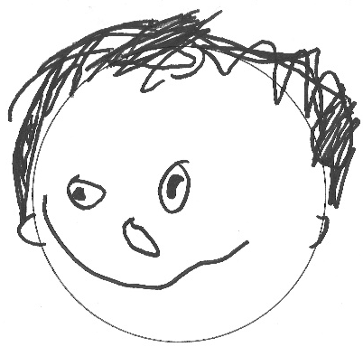
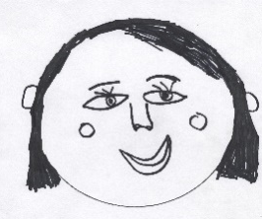

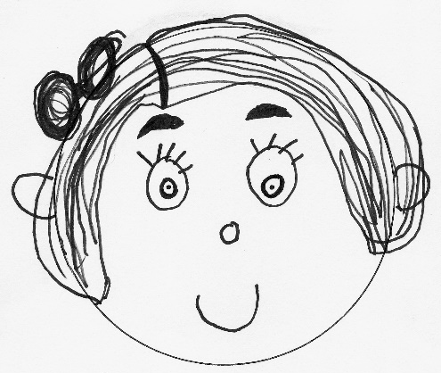

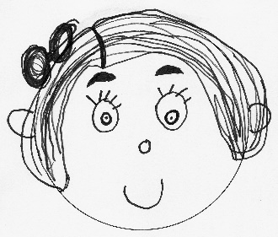

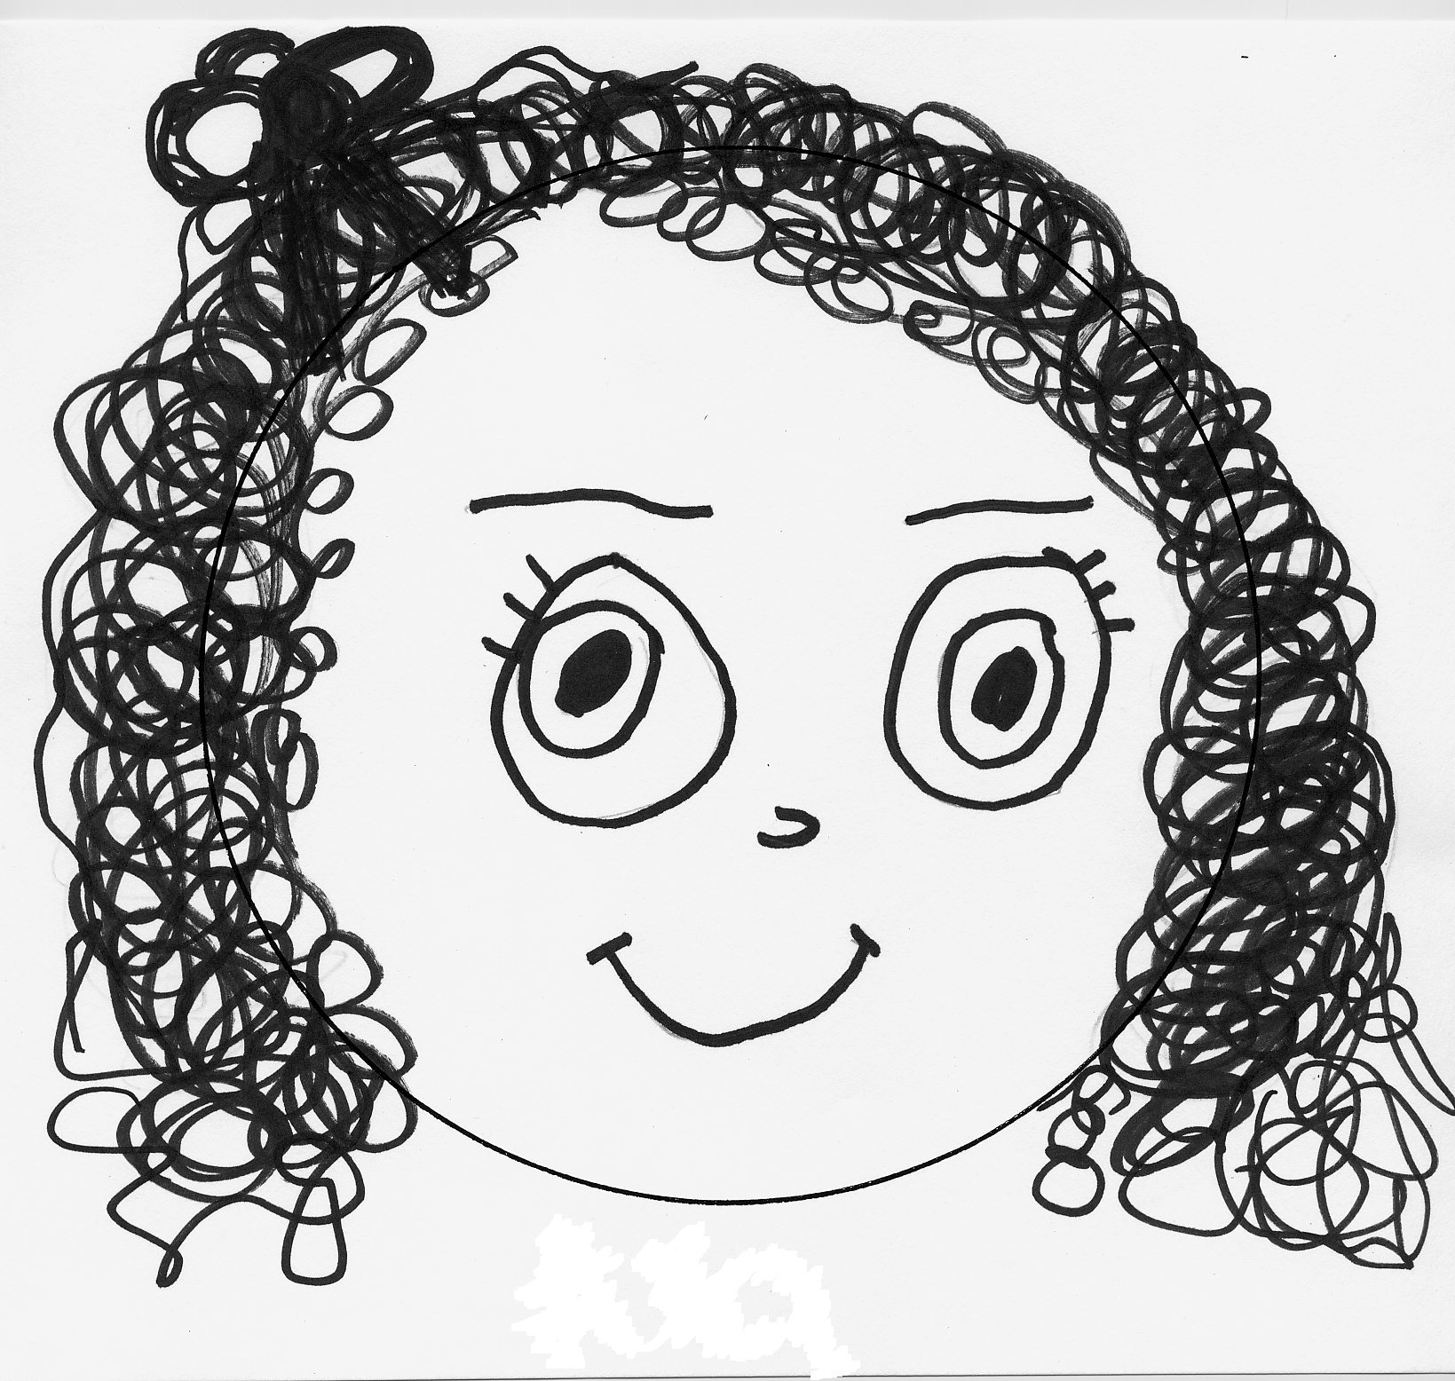

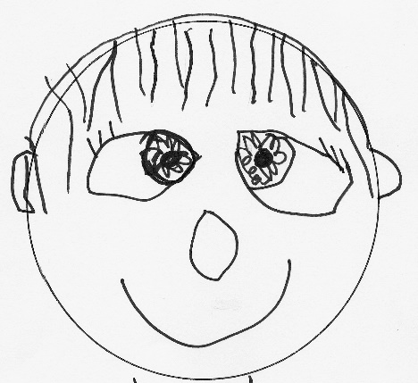
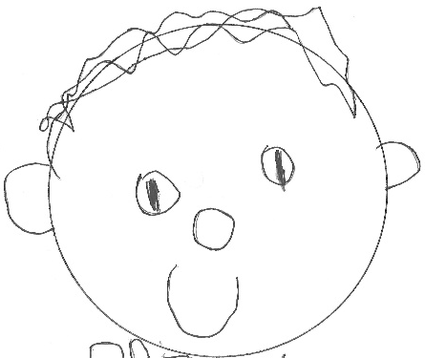

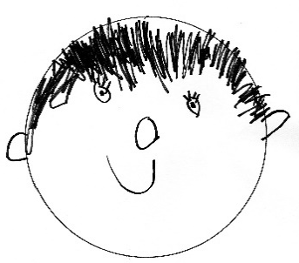

www.firstbaptistpreschoolrva.com

