TABLE OF CONTENTS

Letter from Alex Hamp, Preschool Administrator 1

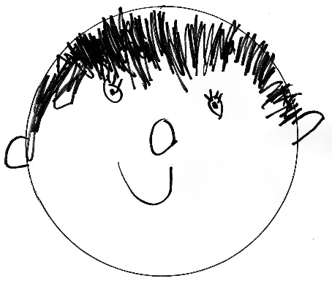
Statement of Philosophy 2-3

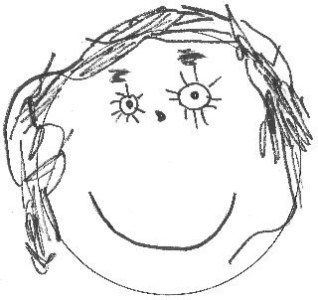
School Policies
Arrival 4
Attendance 4
Birthdays 4
Carpool 4
Center Approach 4
Church Support 4
Class Visits 4
Conferences 5
Diapers 5
Discipline 5
Dress 5
Early Morning Drop-Off 5
Enrichment 6
Enrollment Termination 6
Extended Day Program (Lunch Bunch) 6-7
Fees 7
First STEP Class 8
Field Trips 8
Health 8-9
Insurance 9
Kindergarten 9
Ladder of Communication 9
Late Pick-Up Fees 9
Music……………………………………………………………………………………….9
Parents as Partners………………………………………………………………… 9-10
Parent Teacher Organization (PTO) 10
Placement in Class 10
Safety 11
Scholarships and Fund Raisers 11
School Closings 11
Screenings 11
Snacks 11-12
Toilet Training 12
Faculty Meeting Dates 12
School Year Calendar 13

First Baptist Preschool
2709 Monument Avenue
Richmond, Virginia 23220
hamp@fbcrichmond.org
358-5458, ext. 155

Alex Hamp
Administrator

July 2019

Dear Parents/Guardians,

Welcome to the First Baptist Preschool program! Our teachers are busy planning many exciting learning opportunities for your child. Our school year officially begins on Monday, September 9th.

We invite you and your child to our Class Visits on September 5th and 6th. Your child’s teacher will contact you with a time for your visit. These visits are generally 20 minutes long.

Please read this handbook to become familiar with our school’s policies and procedures. Please return the letter in your packet that states that you have read the information and contacted me if there were any questions. (This is a state regulation.)

Our school provides a warm, supportive, and nurturing environment. We encourage you to share your talents and time with us as we join TOGETHER to make this year an important one in terms of your child’s growth.

Sincerely,

Alex Hamp

STATEMENT OF PHILOSOPHY

WE BELIEVE children need a learning environment which will:

♥ nurture each preschooler as a unique and valuable child of a caring God

♥ encourage the total development of each child (physically, socially, spiritually, emotionally, and intellectually)

♥ encourage a strong feeling of self-confidence and respect for others

♥ provide first-hand opportunities for the child to grow

♥ by observing

♥ by inquiring

♥ by exploring

♥ by creating

♥ by asking

♥ by seeking

♥ and by finding
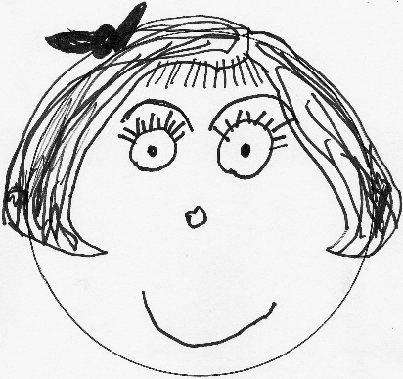
.

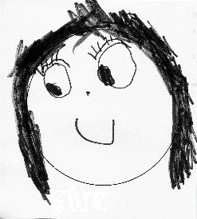

First Baptist Preschool is a religiously exempt preschool located at 2709 Monument Avenue in Richmond, Virginia. Our preschool can serve up to 122 students ranging in age from eight months (by the first day of our school year) through five years. Our preschool utilizes fifteen classrooms in the approximately 250,000 square foot church building. In addition, we use the full size gym and two playgrounds on the property. First Baptist Preschool does not discriminate on the basis of race, color, gender, or national or ethnic origin. All of our teachers are certified annually to be in good health and free from any disability which would prevent them from caring for children. A daily snack or lunch is brought from home. All of our classes have two teachers, a lead teacher and an assistant. Our lead teachers hold a college degree, or have experience that is comparable. Both teachers and assistant teachers are required to have ten hours of staff training annually. Our preschool students and visitors are covered by the Church’s public liability insurance policy.

Because we encourage the total development of each child (spiritual, social, emotional, physical and intellectual), a variety of activities are planned each day to meet individual needs. During the free choice of activities, teachers and assistant teachers will offer guidance, motivation, and encouragement to children on a one-on-one basis or in small groups.

In this manner, we feel we can build upon the concepts already formed and introduce new ones at appropriate times for each child.

Included in the schedule are times for social interaction, which will encourage your child to expand his/her vocabulary and learn to express his/her thoughts and feelings to others.

A chapel time for three, four, and five year olds will include a Bible story, music, and prayer. Music class for three, four, and five year olds occurs once a week. Our Pre-K and 3 year old students visit the Children’s Library and check out books each week.

A balance of large and small motor activities is provided to enhance important physical growth.

It is our desire to provide a warm and caring atmosphere which will nourish personal and spiritual growth. Through association with dedicated teachers, and with age appropriate activities, each child will be encouraged to grow in love and appreciation of a caring God. Mission projects will be offered throughout the school year beginning in September. We hope you will help us teach your child to care for others by participating in our mission projects.

ARRIVAL
Parents/Caregivers need to bring their children into their classrooms. Parking is available in the Mulberry Street parking lot or on Monument Avenue, Mulberry Street, Park Avenue, and the Robinson Street Parking Lot.

CRITICAL SAFETY INFORMATION:
- Please hold children’s hands when walking through the parking lot.
- Please do not allow your child to come into the building alone, to go upstairs, or on the elevator alone (for our Pre-K students).
- Please make sure that your child is WITHIN REACH AND SIGHT AT ALL TIMES when you are on the portico, the sidewalks, or in the parking lot.
- Our parking lot is a cell phone free zone.

To allow the teachers time in the mornings for ample set up and planning, we ask that you arrive promptly at 9:00 a.m. The earliest drop off time is 8:55, unless your child has registered for Early Morning Drop Off. If you arrive after 9:15 a.m., please take your child to either the teacher or assistant teacher so he/she can be greeted.

ATTENDANCE
Please email or text your child’s teacher and email Alex Hamp at hamp@fbcrichmond.org by 9:30 a.m., when your child is sick or will not be attending school for any other reason.

BIRTHDAYS
For ages 2 and up, please come and share your child's birthday with us at school! Please check with your child’s teacher about how they handle birthdays and possible food allergies. Please plan to read one of your child’s favorite books to the class. In addition, some parents like to donate the book to the preschool in honor of their child. Children with summer birthdays will celebrate their half birthdays.

CENTER APPROACH
Each classroom is set up daily with varying learning centers - art, blocks, books, home living/dramatic play, music, nature/science, manipulatives, and sensory table. Children are provided free choice in moving from one area to another with teachers and assistant teachers offering guidance one-on-one or in small groups.

CHURCH SUPPORT
First Baptist Preschool is 73 years old! We are proud of our role in providing the best quality preschool experience for children in the Richmond area. The First Baptist Church Preschool is viewed as a community ministry made available through this facility. First Baptist Church provides our space. The Church appoints an advisory board which meets to review budget, tuition, and needs or concerns expressed by the administrator.

CLASS VISITS
Students and Parents are invited to come visit their classroom on September 5th and 6th at a set time. This gives you and your child the opportunity to explore the classroom with one or two other students and a chance to meet the teacher for 20 minutes. Your teacher will be in contact by August 15th with a time for you to visit.

CONFERENCES
Parent/Teacher Conferences are scheduled on Friday,December 6th. If needed, childcare is available for your enrolled child and his/her siblings. If you have concerns at any other time, please reach out to your child’s teacher or Alex by email, or by voice mail at 358-5458, extension 155, with your questions or concerns. We will also offer conferences in May for Prek, or for any parent who requests it.

DIAPERS
A well-stocked diaper bag includes 3 diapers, wipes, plastic bag, and a complete set of clothes (even socks!). Wet pants are not the only accidents at school. Spilled water or paint often necessitates changing a child's clothing. Please label the diaper bag and clothing.

DISCIPLINE
The following methods are used by our faculty to encourage cooperative behavior:
1. Giving positively worded directions: You may sit on the floor or on a chair. Walk inside. Run outside or in the gym. Remember to use your words.
2. Redirection: Substitute a positive activity for a negative activity. (You may throw a beanbag - we use blocks for building.)
- Distraction: Change the focus of the activity.
4. Positive reinforcement: “Try to catch a child being good” affirming a child’s appropriate behavior.
5. Active Listening: Helping the child determine why there is a problem and helping the child acknowledge his/her feelings and/or reaction.
6. Separation from the group: When all of the above fails, only then is a child briefly (less than 5 minutes) separated from his/her classmates. The child will always be within sight of the teachers.
7. Better Choice: We use the phrase “making a better choice” instead of time-out.

PHYSICAL PUNISHMENT AND SHAMING METHODS ARE NEVER USED.

DRESS
Since children learn by engaging in "hands on" experience, we will be participating in fun activities such as painting, play dough, gluing, etc. Please send your child to school dressed comfortably, in play clothes which will wash easily. For your child’s safety, please have him/her wear tennis shoes. Sandals, clogs, cowboy boots, cleats, and crocs are not safe for children at school. Please be sure to label all coats or any removable clothing.

EARLY MORNING DROP-OFF
This option will be available beginning Monday, September 9th. Enrolled children may come at 8:00 a.m. Children must be enrolled for the entire school year. A completed enrollment form (found in your summer packet) is required by August 15th. The cost is as follows: 1 morning a week for the school year is $300; 2 mornings, $600; 3 mornings, $900; 4 mornings, $1200; and 5 mornings, $1500. Payment can be paid in your monthly tuition, or in two installments: September 15th & January 15th. Drop-Ins are allowed, if there is space, and cost is $12. Please email Alex at hamp@fbcrichmond.org to check on availability for drop ins. No same morning requests! Please request at least 12 hours before.

ENRICHMENT
In addition to the regular classroom schedules, all children in the 3-4’s and Pre-K classes attend the following: music class each Monday, Chapel service each Wednesday, and a library visit each week. We also offer enrichment classes, such as Soccer Shots or Wee Little Arts, in 6-8 week sessions. These are held afterschool at an additional cost.

ENROLLMENT TERMINATION POLICIES
It is understood that a child admitted to First Baptist Church Preschool is to be enrolled for the entire school year (September - May). If it becomes necessary to withdraw the child from school, the parents must give a 4 week notice to the administrator. This notice must be in writing. The parents are responsible for the full yearly tuition unless the child's space can be filled. The only exceptions to this may occur if a child is withdrawn due to the recommendation of a physician or due to the permanent move of a family from the Richmond area.

First Baptist Preschool reserves the right to terminate the school contract and require the withdrawal of any child enrolled in the program if the school, in its sole discretion, considers such withdrawal to be in the best interests of the school. If the withdrawal is required by First Baptist Preschool, the affected family shall receive a pro rata refund of any tuition payments previously made, depending upon the date of the withdrawal.

EXTENDED DAY PROGRAM (LUNCH BUNCH)
Lunch Bunch will begin on the first day of school, September 9th. The purpose of this program is to provide both additional center time and gross motor skill development for your child. The cost for this program is as follows:

Day | 1 hour | 2 hours | 3 hours
Monday | $250 | $500 | $750
Under 2 | $350 | NA | NA

Day | 1 hour | 2 hours | 3 hours
Tuesday, Wednesday, or Thursday | $300 | $600 | $900
Under 2 | $400 | NA | NA

Day | 1 hour
Friday | $300
Under 2 | $400

Children must be enrolled for the entire school year. A completed enrollment form is required by August 15th. Payment may be made in your monthly tuition, or in two payments: September 15th and January 15th. We have a drop-in option, if there is space available, for days when you may need a later than normal pick-up time. You must have prior approval, and the cost is $12 per child per hour. Please do note that in the past few
years there have been days when Extended Day is full, and we could not have drop ins. Please email Alex at hamp@fbcrichmond.org when this is needed to ensure there is space.

EXTENDED DAY PROCEDURES
- Your child will need to bring a packed lunch and water cup. PLEASE REMEMBER WE ARE A PEANUT FREE SCHOOL, AS YOU MAKE YOUR CHILD’S LUNCH. No juice boxes or gogurts, as they prove to be quite messy! Please send in a spoon if your child’s lunch requires one. Please label all non-disposable containers.
- Your child will have the opportunity to play in a multi-age setting in the centers and with manipulatives and games set on the table after the lunch hour. An open ended art table will be offered. There will be enrichment classes offered, at an additional cost, during extended day. We will also go outside or the gym for gross motor development. Children will eat a snack brought from home at 2:30.
- If your child needs a nap, nap time will be approximately 1.5 hours in the Bunny Room (140E). Please send in a blanket and special lovey or stuffed animal for nap. If you need to pick up your child from the nap room before 2:45 please stop by 180A so the teacher can text the room and your child will be brought out to you.
- Please be prompt in picking your child up on the hour. LATE PICK-UPS WILL BE ASSESSED A LATE FEE OF $5 FOR EVERY 10 MINUTES AFTER THE HOUR. If YOUR CHILD IS NOT PICKED UP BY 3:15, HE/SHE WILL BE TAKEN TO THE CHILDREN’S MINISTER IN THE MAIN OFFICE. TEACHERS ARE NOT EXPECTED TO STAY PAST 3:10.
- Unfortunately due to the popularity of Extended Day, we will not be able to change days if your child is absent on his/her extended day.

FEES (9am-12pm tuition)
Registration: A non-refundable registration fee of $50.00, which is applied to your tuition, is required with each application. This tuition chart below is for morning classes only! Tuition can be paid by check or online at www.firstbaptistpreschoolrva.com. There will be a service charge to cover the fee charged to us by the bank, for any and all checks returned to us for insufficient funds. When paying online we ask, if possible, that you pay using your debit card so the church does not incur the fees from credit cards. Church members receive a 5% discount on tuition. There is a $100 sibling discount for the 2nd (and subsequent) child/ren IN THE SAME FAMILY who are enrolled AT THE SAME TIME.
Date due | 2 day class | 3 day class | 4 day class | 5 day class | Pre-K
 | $2200 | $2800 | $3400 | $3800 | $4650
Reg + $150 deposit | $200 | $200 | $200 | $200 | $200
07-15-18 | $500.00 | $650.00 | $800.00 | $950.00 | $1113.00
09-15-18 | $500.00 | $650.00 | $800.00 | $950.00 | $1113.00
01-15-19 | $500.00 | $650.00 | $800.00 | $950.00 | $1113.00
03-15-19 | $500.00 | $650.00 | $800.00 | $950.00 | $1113.00
Or monthly (9mo) Sep-May | $222.00 | $289.00 | $356.00 | $950.00 | $495.00

The tuition chart above is for those who paid the registration fee/deposit of $200. If you are unsure, please contact Alex at hamp@fbcrichmond.org. The monthly payment shown above is based on 9 months (September to May). ALL MONTHLY TUITION IS DUE THE 15TH OF EACH MONTH.

ALL TUITION MUST BE PAID BY MAY 15TH, 2020, OR THERE WILL BE A 5% LATE FEE ON THE BALANCE.

FIRST STEP CLASS
We are excited to partner with the ASK Cancer Foundation to provide preschool for children or siblings who are affected by cancer or other childhood diseases. We are one of two preschools in the country who have this special partnership! The First STEP (Socialization Through Enriched Play) class meets on Tuesdays and Thursdays.

FIELD TRIPS
Because we feel it is important for children to have first-hand experiences in the world around them, our Pre-K children will be taking several field trips during the year. Parents are always welcome to join their child on a field trip. We also welcome suggestions for field trips. (Due to insurance regulations, siblings of our students may not accompany parent helpers on field trips.)

HEALTH
The Commonwealth of Virginia School Entrance Health Form, a record of a completed physical examination and up-to-date immunizations, IS REQUIRED BY AUGUST 15, 2019 FOR ALL NEW STUDENTS. This form is available from your pediatrician or our church’s Preschool website (www.firstbaptistpreschoolrva.com). For returning students, an updated immunization record is needed. Up-to-date immunization information is also required every six months for children under the age of two years. Please make us aware of any atypical health information, including, but not limited to, allergies, tendency to seizures or chronic illness.

As a religiously exempt preschool, we require that our students be current in all immunizations as set by the Centers for Disease Control for the safety and health of all children at First Baptist Preschool. Decisions on exceptions will be made on an individual basis, considering the recommendation of the relevant pediatrician.

Prescription medication, with the exception of epi-pens and inhalers, is generally not administered by our faculty. Parents are required to complete a form authorizing the administration of the epi-pen/inhaler. This form is available from Alex Hamp.

Skin products, such as sun screen and insect repellant, will not be administered by our preschool. Parents should be mindful that children will be outside at least 30 minutes per day and should apply these products as needed before the child arrives at preschool. Exception: Diaper ointment or cream will be applied as needed, but only when provided by the parent. Please send ointment, marked with your child’s name, to be kept in your child’s classroom.

For the protection of your child and others in our preschool, parents must keep him/her at home when he/she has any of the following symptoms:
- A temperature of 100 degrees or more (without fever-lowering medication)
- A heavy nasal discharge
- Cough that interrupts child’s play
- Vomiting or diarrhea within the past 24 hours
- Any communicable disease
- Head lice/nits

Please note that there are other symptoms of illness that may keep your child out of school, which are not listed above. Please be vigilant as to unusual symptoms or behaviors in your
child which might indicate illness. The preschool will also be observant and if your child becomes ill at school, you will be notified to come for him/her. ANY CHILD SENT HOME
DUE TO ILLNESS WILL NOT BE READMITTED THE FOLLOWING DAY WITHOUT A DOCTOR’S NOTE STATING THAT THE CHILD IS READY TO RETURN TO SCHOOL.

Your child may also need to stay home in the two following situations:
- When he/she is fussy, cranky and generally not him/herself, it is often the first sign of ensuing illness.
- When you have one sick child at home, it is frequently wise to keep siblings home also, as they have already been exposed to the illness in question and are likely to transmit it to their classmates as well.

We ask that you use your discretion in these two situations, and help us prevent outbreaks of illness in our school. This will benefit your children and all their classmates.

Please notify the school immediately if your child contracts a communicable disease. PLEASE NOTE: YOUR CHILD MUST BE SYMPTOM FREE, WITHOUT MEDICATION, FOR AT LEAST 24 HOURS BEFORE RETURNING TO SCHOOL.

INSURANCE
All children enrolled in FBC Preschool are covered by accident insurance while at school. Claim forms are available from the administrator.

KINDERGARTEN
After First Baptist, our "graduates" attend a variety of public (Richmond, Hanover, Henrico, and Chesterfield) schools and private schools.

THE LADDER OF COMMUNICATION
Our goal is to maintain a quality program. We are interested in suggestions and questions. Please discuss your classroom concerns with your child’s teacher. Please address your administrative concerns directly to Alex Hamp (hamp@fbcrichmond.org).

LATE PICK-UP FEES
Dismissal is at noon for all classes, except for Pre-K which is at 1PM. If a child is not picked up by these times, the teacher will try to contact the parents first, and then contact the persons listed on the emergency card. A late pick up will be assessed a fee of $5 for every 10 minutes, or portion thereof. Emergency situations will be taken into account when a parent calls to inform the receptionist at 358-5458, Ext 110.

MUSIC
Our 3 year old and Pre-K classes meet every Monday for Music. We have fun singing and enjoying creative movement, while also learning music concepts and how to play instruments. We showcase what we have learned for our parents at our Christmas Songfest and Graduation.

PARENTS AS PARTNERS
As a young child separates from his/her family for the first time, much understanding and cooperation is needed between the teacher and family. As parents you know your child, his/her unique characteristics, and special needs. This information is important to the teacher in helping to meet your child's needs.

Communication between home and school is very important. We ask that you notify us by email or written note regarding changes in your child's schedule, carpool changes, or changes at home which may affect your child. Any changes in carpools or transportation arrangements require advance written notification. We will not allow children to leave school with someone other than their parents without proper written permission. Also, for your child’s emotional security, please explain any changes in your child’s regular schedule to him/her.

We ask that you be involved this year. Share your talents with your child’s class. Be concerned with your child’s progress. Please, visit us often!

If you wish to discuss your child's development with his/her teacher, please call for an appointment. Regularly scheduled conference days are listed in the school calendar. Your input is important - don't hesitate to call or email your child’s teacher!

PARENT TEACHER ORGANIZATION
The Parent Teacher Organization (“PTO”) is a social group that exists to strengthen the relationship between parents, teachers, and the community. The PTO hosts and sponsors events that are both family friendly and parent focused to create time for fellowship outside of the school day. Our President for the school year is Sally Branch. Annual dues are $20 per family and go toward participation costs associated with the events throughout the school year, such as Pizza in the Park, “Friendsgiving” Pot Luck Dinner, Mom’s Night Out, and much more. Summer meet-ups and organized play groups are also a benefit of the PTO. Make friends, support our preschool and enhance your child’s school experience. Join today!

PLACEMENT IN CLASS
One of the most frequently asked questions is: “How do you place children in a particular class?” The following information will help answer this question.
- Parents first choose the number of days their child will attend. Most times a family will receive their first choice.
- When there will be at least two classes (for example: Pre-K classes), the children are divided by chronological age and gender.
- ARE THERE EVER EXCEPTIONS? We honor families’ requests to have their twins or other close relatives (such as cousins) in different classes. We also follow the recommendations of a child’s IEP, if applicable.
- Class lists are subject to change.

SAFETY
At First Baptist Preschool, your child’s safety is our top priority. All of our teachers and assistants are CPR and First Aid certified. We have an off duty City of Richmond police officer who provides daily security for us. In addition, your child will participate in monthly fire drills, as well as annual tornado, earthquake, intruder, and evacuation drills. In the event that our preschool is to be evacuated, we will proceed to the Robinson Street parking lot. You would then be contacted by your child’s teacher.

- Our parking lot and building is a busy one! Please be mindful that our parking lot is one way. Please also make sure your child is within reach and in sight AT ALL TIMES when you are on the portico, the sidewalk, the parking lot, and in the building.

Every effort will be made to prevent accidents, but in the case of any accident needing more than simple first aid, the parents will be notified immediately.

Siblings and friends may visit a classroom only when accompanied by a parent or caregiver who assumes full responsibility for them.

Our staff is obligated by law to report all suspected cases of child abuse and neglect in accordance with 563.1-248.3 of the Code of Virginia.

SCHOLARSHIPS AND FUNDRAISERS
Limited scholarships are available beginning in January for the following school year. These are provided solely on the basis of need. Applications are available online. Your application should be returned with your child’s registration form.

Our Preschool has several events each school year which help to raise money for our school and our scholarship fund. This includes a book fair, school pictures by Howl Dog, Square 1 Art Fundraiser, and class pumpkin silent auctions. There may be other events as well that will serve as fundraisers for our preschool.

SCHOOL CLOSINGS
EMERGENCY/INCLEMENT WEATHER SCHOOL CLOSING POLICY:
- School closing or delays are determined by many factors, including the Church’s decision to open. All closings will be announced through email, on our Facebook & Instagram pages, and through the Remind text messaging system. We do not follow one school system’s decision!
- School will be closed if our facility does not have water or electricity at 8:00 a.m.
- These days are NOT made up!

*The safety of your children and our faculty is our FIRST priority.

SCREENINGS
We offer two screenings for children. Each fall we offer speech screenings for all age groups through Speech Connection. The Pre-K students also participate in PALS (Phonological Awareness Literacy Screening) in the fall and spring.

SNACKS
Please have your child bring his/her own snack to school each day. WE ARE A PEANUT FREE SCHOOL. The snack needs to be labeled with your child’s name and the date. If your child's snack needs to be refrigerated, please attach a note directly to it. Ice water using church pitchers is served to each class. Please provide a small plastic cup (6-8 oz.) with your child’s name on it, each school day. The cup will be sent home each day for cleaning. Foods easily causing choking, such as, but not limited to, hard candy, popcorn, seeds, nuts, and uncut grapes, will NOT be served to children three years of age or younger. (Children under three can be served grapes that are cut into quarters.)

TOILET TRAINING
We recognize the uniqueness of each child and do not have a policy requiring children to be toilet trained by a certain age in our younger classes. For our Pre-K classes, however, all children do need to be toilet trained (no pull ups). It is also required for participation in the Enrichment Classes afterschool. Do let your child’s teachers know when you begin toilet training at home. We will do our best to reinforce what you are doing. If you send your child to school in pull-ups, please make sure they are the detachable type (Huggies). If your child is able to verbalize his/her bathroom needs and has infrequent accidents (one or two times a week), then he/she is probably ready to wear underwear to preschool. Please help us by making sure your child is ready for this transition!

*PRESCHOOL FACULTY MEETINGS*

2019-2020 SCHOOL YEAR
Please mark your calendars:
All children (including Pre-K) are dismissed at 12:00 noon for teacher training,
and there is no Lunch Bunch, on the following Mondays:

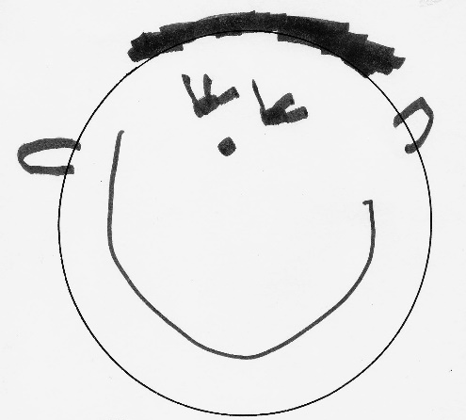
November 4, 2019
December 16, 2019

February 4, 2020
March 25, 2020
May 20, 2020
May 23, 20

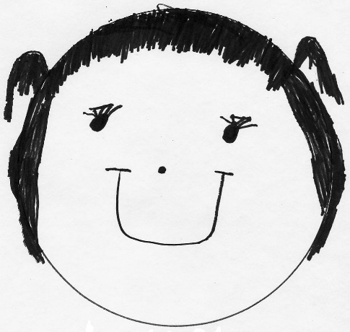

2019-2020 Preschool Calendar

2019
Classroom Visits September 5 & 6
First Day of School & Lunch Bunch September 9
Election Day - No School November 5
Thanksgiving Holiday - No School November 27, 28, & 29
Parent/Teacher Conferences - No School December 6
Christmas Songfest (Older classes) December 18,11:30 am
Christmas Holiday - No School December 23 ~ January 3
2020
Preschool classes resume January 6
Registration for 2018-2019 school year begins January 8
Martin Luther King, Jr./National Day of Service - No School January 20
Presidents’ Day - No School February 17
SMALL WORLD Program (Pre-K classes) March 20, 11 am
Spring Break - No School April 6-10
Easter Monday-No School April 13
Graduation (Pre-K classes) May 21, 11:30 am
Last Day of Preschool May 21
Faculty Workday May 22

Summer Solution: May 26 ~ June 12, 2020

Noon dismissal for PreK/No Extended Day for faculty meetings:
November 4 & December 18, 2019
February 4th, March 20th & May 18th & May 21, 2020

“Like” us on Facebook under
First Baptist Preschool
Or follow us on Instagram under
firstbaptistpreschoolrva

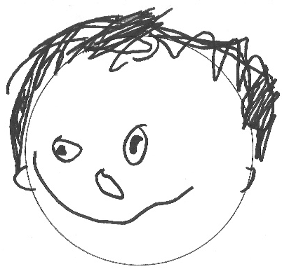
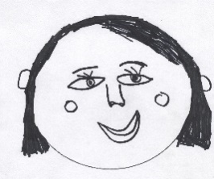

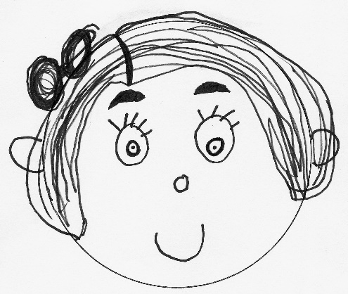

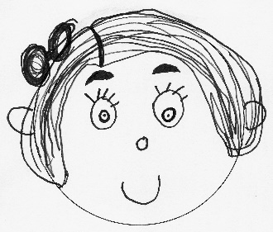

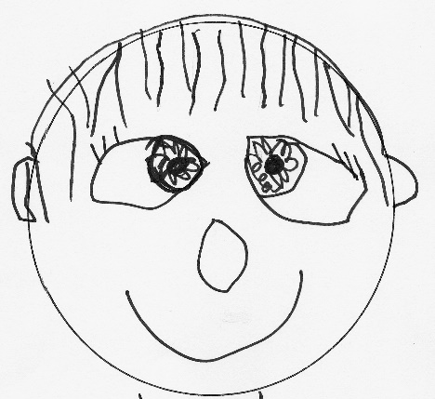
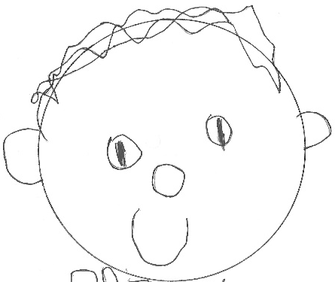

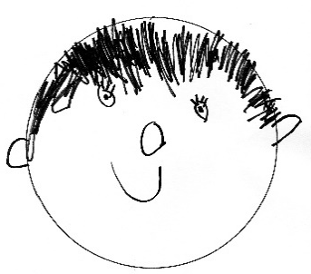

www.firstbaptistpreschoolrva.com

